HYPER-PARAMETER TUNING OF RANDOM FOREST ALGORITHM FOR MAIZE LEAF DISEASE DETECTION AND CLASSIFICATION

BY

TAOFIQ OMOTOWO ALABI
24/11006

JOSEPH SARWUAN TARKA UNIVERSITY, MAKURDI
FEDERAL POLYTECHNIC STUDY CENTER, BAUCHI
DEPARTMENT OF COMPUTER SCIENCE

NOVEMBER, 2025

DECLARATION
I declare that the work in this project entitled “Hyper-Parameter Tuning Of Random Forest Algorithm For Maize Leaf Disease Detection And Classification” has been performed by me in the Department of Computer Science, Joseph Sarwuan Tarka University, Makurdi. The information derived from the literature has been duly acknowledged in the text and a list of references is provided.

_Taofiq Omotowo Alabi _______________________ _____________________
Name of Student Signature Date

CERTIFICATION
This project dissertation entitled “Hyper-Parameter Tuning Of Random Forest Algorithm For Maize Leaf Disease Detection And Classification” by TAOFIQ OMOTOWO ALABI meets the regulations governing the award of the degree of Post Graduate Diploma in Computer Science of the Joseph Sarwuan Tarka University, Makurdi and is approved for its’ contribution to knowledge and literary presentation.

Suberu Yusuf __ __________________ _____________________
Supervisor Signature Date

__________________________________ __________________ _____________________
Head of Department Signature Date

__________________________________ __________________ _____________________
Dean, School of Postgraduate Studies Signature Date

DEDICATION
I begin by expressing my deepest gratitude to the Almighty Allah for bestowing upon me the strength, guidance, and blessings throughout my journey. I dedicate this work to my late parent (AbdulSalam Amosa Omotowo and Hafsat AbdulSalam Omotowo).

ACKNOWLEDGEMENT
I begin by expressing my deepest gratitude to the Almighty Allah for bestowing upon me the strength, guidance and blessings throughout my PGD. journey. Indeed, His divine grace has illuminated my path and granted me the perseverance to overcome challenges.
I would like to express my heartfelt gratitude to my late parents (AbdulSalam Amosa Omotowo and Hafsat AbdulSalam Omotowo) for their sacrifices that have shaped me into the person I am today. I pray Allah continues to forgive and stregthen them.
A special word of thanks to my supervisor, Mallam Suberu Yusuf for his guidance, expertise, and invaluable feedback throughout this process. Your mentorship has been instrumental in shaping my research and academic growth. I am indebted to my lecturers for their profound knowledge, insightful teachings, and dedication to nurturing our intellectual curiosity. Your passion for education has inspired me beyond measure. To the PG Coordinator (Lele Muhmmad), Head of Department (Kuliya Muhammed), thank you for fostering an environment of academic excellence and providing the resources necessary for our success.

ABSTRACT
This study addresses the critical challenge of automated plant disease detection by developing and validating an optimized machine learning pipeline for maize leaf disease classification. The study introduces a hybrid architecture that combines deep learning-based feature extraction with hyperparameter-optimized Random Forest classification to achieve robust disease identification. The method employs CNN architecture of ResNet50 which is pretrained on ImageNet to extract discriminative features from the maize leaf images, generating 2,048 dimensional feature vectors. These features are then classified using a Random Forest algorithm whose hyoerparameters have been optimized through Random SearchCV optimization. The model was trained and evaluated on the maize dataset comprising of 3,823 images across four classes: Common Rust (1,306 images), Gray leaf spot (574 images), Northern Leaf Blight (985 images) and healthy leaves (958 images). The dataset was partitioned using stratified sampling with an 80-20 train-test split to ensure representative class distribution. The optimized model achieves 92.4% overall accuracy and macro-averaged F1-score of 91.8%. Classwise analysis revealed high performance across all categories: Common Rust (F1-score: 93.6%), Gray Leaf spot (F1-score: 87.8%), Northern Leaf Blight (F1-score: 91.8%) and healthy leaves (F1-score: 93.9%). The hyperparameter optimization process identified the optimal configuration as 347 trees with maximum depth of 28 using square root feature sampling and minimum 4 samples per split which provided a better improvement compared to the deafult parameter settings. The proposed model achieved a higher performed in terms of all the evaluation metrics that were used in the study. The output in terms of scores was also higher than that of the compared study.
Table of Contents
DECLARATION i
CERTIFICATION i
DEDICATION ii
ACKNOWLEDGEMENT iii
ABSTRACT i
CHAPTER ONE 1
INTRODUCTION 1
1.1 Background of study 1
1.2 Statement of the Problem 2
1.3 Aim and Objectives 2
1.4 Significance of the Study 3
1.5 Organization of Study 3
CHAPTER TWO 5
LITERATURE REVIEW 5
2.1 Introduction 5
2.2 Machine Learning Algorithm 5
2.3 Classification Algorithm 5
2.3.1 Random Forest 6
2.4 Deep Learning 7
2.4.1 Convolutional Neural Network (CNN) 7
2.5 Dimensionality Reduction (DR) Technique 8
2.5.1 Feature Extraction 9
2.6 Related Work 9
2.7 Summary of related work 12
2.8 Research Gap 14
CHAPTER THREE 15
RESEARCH METHODOLOGY 15
3.1 Introduction 15
3.2 Implementation Setup and System Specification 15
3.3 Image/Data Collection 17
3.4 Image Preprocessing 17
3.5 Image Segmentation 17
3.6 Feature Extraction 18
3.7 Hyperparameter Tuning using RandomSearchCV 19
3.8 Classification 20
3.9 Performance Metrics 20
3.10 Expected Result 21
CHAPTER FOUR 22
RESULT AND DISCUSSION 22
4.1 Introduction 22
4.2 Feature Extraction Experiment 22
4.3 Hyperparameter Tuning Experiment 24
4.4 Experimental Result Analysis/Comparison 25
4.5 Model Deployment 26
CHAPTER FIVE 31
SUMMARY, CONCLUSION AND RECOMMENDATION 31
5.1 SUMMARY 31
5.2 CONCLUSION 31
5.3 RECOMMENDATIONS 31
APPENDIX 33
REFERENCE 35

CHAPTER ONE

INTRODUCTION

1.1 Background of study
Plant disease detection is crucial in agriculture because farmers must constantly assess if the produce they're harvesting is of acceptable quality (Varshney et al., 2022). It is critical to treat this seriously because it can cause major difficulties in plants, affecting product quality, quantity, or productivity. Plant diseases have had an influence on society and history around the world. Several countries such as the United States affected with great economic losses due to plant diseases which can affect any type of plant. Plant leaves are the most sensitive and display disease symptoms earliest; from the beginning of their life cycle until they're ready to be picked, the crops must be monitored for illnesses (Rossman, 2009).
Maize (Zea mays L.) is one of the most vital cereal crops globally, serving as a staple food for over 1.2 billion people and a critical feedstock for livestock and industrial applications (Erenstein et al., 2022). However, maize production faces significant threats from foliar diseases such as Common Rust (Puccinia sorghi), Gray Leaf Spot (Cercospora zeae-maydis), and Northern Leaf Blight (Exserohilum turcicum), which collectively account for yield losses of 15–70% in sub-Saharan Africa alone (Nsibo et al., 2024). Traditional disease identification relies on manual scouting by farmers or pathologists, a process that is labor-intensive, time-consuming, and often inaccurate due to the visual similarity between early-stage symptoms (Bachhal et al., 2024).
Recent advances in machine learning (ML) and computer vision have demonstrated remarkable potential for automating plant disease detection. Notably, convolutional neural networks (CNNs) have achieved high accuracy in classifying diseases using benchmark datasets like PlantVillage (Ali et al., 2024) . However, CNN-based models face practical challenges in resource-constrained agricultural settings, including high computational costs, large training datasets, and limited interpretability (Iftikhar et al., 2024). In contrast, Random Forest (RF) algorithms offer a compelling alternative due to their computational efficiency, robustness to overfitting, and inherent feature importance analysis.
A critical gap persists in optimizing RF models for plant disease tasks. Existing studies often use default hyperparameters, despite evidence that tuning parameters like tree depth (max_depth) and feature subsets (max_features) can improve accuracy by 10–20% (Salman et al., 2024). This study addresses this gap by systematically optimizing RF hyperparameters for maize disease classification, using the PlantVillage dataset as a benchmark. The study combines; transfer learning with ResNet50 for discriminative feature extraction and bayesian optimization (via Optuna) to efficiently explore hyperparameter spaces.

1.2 Statement of the Problem
Maize leaf disease detection remains a critical challenge in sustainable agriculture, where timely and accurate diagnosis can mean the difference between a bumper harvest and catastrophic yield loss. Despite significant advances in machine learning-based plant disease classification, fundamental gaps persist in both study and practical implementation. The gap found in literature include performance limitations of conventional approaches and neglect of hyperparameter optimization in hybrid models. The study by (Panigrahi et al., 2020) uses various machine learning algorithm to detect maize leaf disease and classify but it suffers from neglect of hyperparameter optimization by using the default scikit-learn parameters and also uses the default feature extraction technique. This study intend to optimize the random forest algorithm and also use Convolutional Neural Network (CNN) for feature extraction, thereby, solving the problem found in (Panigrahi et al., 2020).

1.3 Aim and Objectives
The aim of the study is to develop an optimized model for four classes of maize leaf disease detection and classification using Random Forest Algorithm and Convolutional Neural Network (CNN).
The following are the objectives:
- To use CNN for feature extraction in the model pipeline building
- To perform hyperparameter tuning on Random Forest algorithm
- To use the evaluation metrics to determine the performance of the model.

1.4 Significance of the Study
Creating an enhanced Random Forest model to classify maize leaf diseases marks a significant breakthrough in the fusion of agricultural technology and machine learning. This study goes beyond the traditional focus on accuracy to provide a practical, easy-to-understand, and efficient solution that caters to the constraints faced by real-world farmers. Through meticulous optimization of hyperparameters in a hybrid CNN-RF architecture, this study fills a crucial void in plant disease diagnosis. While current deep learning models boast high accuracy rates, their impracticality for widespread field use due to computational requirements and lack of transparency has been a major obstacle. The impact of this study is far-reaching, offering valuable insights to both agricultural practices and machine learning techniques.

1.5 Organization of Study
This study comprises of five main sections:
i. Chapter One: Introduction, this section provides the background, aim, objectives, significance and scope of the project.
ii. Chapter Two: Literature Review, this section presents specific discussions and reviews of existing models and theories related to this research.
iii. Chapter Three: Methodology, this section outline the steps and methodology used to design the model, from the dataset collection to the model training till deployment.
iv. Chapter Four: Results and Discussions, this section details the outcomes of the entire study and also provides a robust discussion about the results obained.
v. Chapter Five: Summary, Conclusion and Recommendation, this section presents summary of the entire study, provides a conclusion and then provide recommendation for future development and improvement.

CHAPTER TWO

LITERATURE REVIEW

2.1 Introduction
Recent advancements in the field of machine learning have brought about significant changes in the way plant diseases are detected, although there are still challenges to overcome in order to optimize models for practical use in agriculture. Researchers have primarily focused on two main approaches: deep learning methods that offer high accuracy but lack transparency and efficiency, and traditional machine learning techniques that provide interpretability but struggle with complex image patterns. Random Forest have shown promise in agricultural settings due to their robustness and ability to interpret feature importance Panigrahi et al., (2020) . However, the performance of these methods heavily relies on the proper tuning of hyperparameters, a crucial aspect that is often overlooked. This section mention various literature related to the scope of this study.

2.2 Machine Learning Algorithm
Machine learning is a concept focused on enhancing future performance through the analysis of past experiences, specifically historical data. This field is dedicated to the development of automated learning techniques that allow algorithms to adjust and improve themselves without human interference. To tackle complex data issues, machine learning utilizes various algorithms tailored to specific problems. Experts emphasize that there is no universal algorithm that can solve all problems effectively. The choice of algorithm depends on factors such as the nature of the problem, the complexity of variables, the most suitable model, and other relevant considerations Mahesh, (2020). Figure 2.1 shows various types of machine learning technique. Figure 2.2 shows a quick rundown of some of the most regularly used machine learning algorithms.

2.3 Classification Algorithm
In the realm of machine learning, supervised learning involves the process of teaching a model to understand the relationship between input and output data through labeled examples. By analyzing training data that contains a collection of input-output pairs, a function is derived to make predictions (Mahesh, 2020). Some of the key supervised machine learning algorithms that focus on classification are Logistic Regression, Naïve Bayes, Perceptron, Support Vector Machine, Boosting, Decision Tree, Random Forest (RF), Neural Networks, Bayesian Networks, and more.
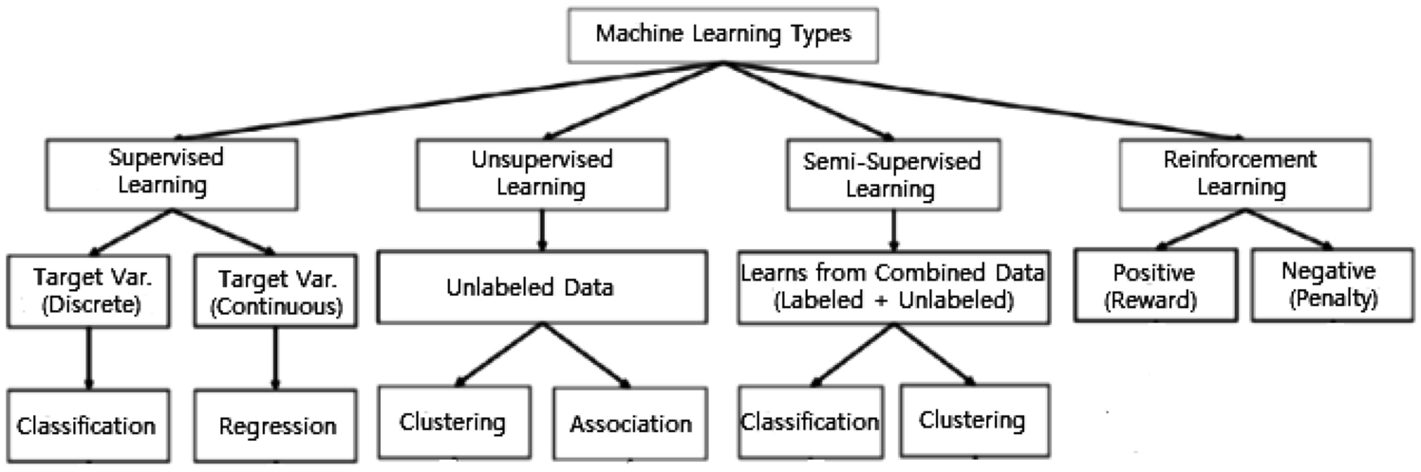

Fig 2.1: Various types of machine learning techniques (Sarker, 2021)
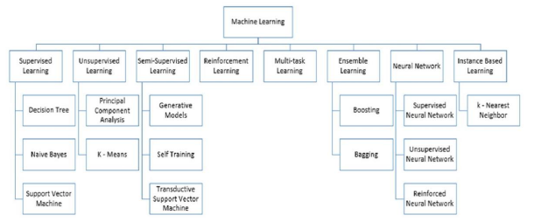

Fig 2.2: Machine Learning Algorithm (Mahesh, 2020)

2.3.1 Random Forest
This algorithm utilizes a collection of randomized decision tree classifiers as its learning methodology. During training, it generates numerous decision trees. When evaluating a testing dataset, it assigns class labels through a voting process conducted by each classification tree. The final classification is determined by the majority vote among the trees. To enhance accuracy, the algorithm incorporates bagging and feature randomness in the construction of each tree. The goal is to develop a diverse forest of trees that are uncorrelated, resulting in more precise performance predictions compared to a single tree (Panigrahi et al., 2020). A random forest is a machine learning model utilized in classification and forecasting. This technique utilizes the concept of decision trees, con-structing a collection of decision trees and aggregating their outcomes to generate the ultimate prediction. Every decision tree inside a random forest is constructed using random subsets of data, and each individual tree is trained on a portion of the whole dataset. Subsequently, the outcomes of all decision trees are amalgamated to derive the ultimate forecast (Salman et al., 2024).

2.4 Deep Learning
Deep learning is a machine learning concept based on artificial neural networks. Deep neural networks typically consist of more than one hidden layer, organized in deeply nested network architectures. Furthermore, they usually contain advanced neurons in contrast to simple ANNs. That is, they may use advanced operations (e.g., convolutions) or multiple activations in one neuron rather than using a simple activation function. These characteristics allow deep neural networks to be fed with raw input data and automatically discover a representation that is needed for the corresponding learning task. This is the networks’ core capability, which is commonly known as deep learning (Janiesch et al., 2021).

2.4.1 Convolutional Neural Network (CNN)
Before Convolutional Neural Networks gained popularity, computer recognition problems involved extracting features out of the data provided which was not adequately efficient or provided a high degree of accuracy. However in recent times, Convolutional Neural Networks have attempted to provide a higher level of efficiency and accuracy in all the fields in which it has been employed in most popular of which are Object Detection, Digit and Image Recognition. Since the beginning, the basic idea behind working of Neural Networks is that it is to mimic the working of human brain to the highest degree possible. Convolutional Neural Network contributes to this by working with the visual sensory organs of the living beings and in process recognizing various types of object be it Digit, Image or a particular action in any object using a string of various techniques followed in a particular order i.e. Convolutional Operation, ReLu Layer, Pooling, Flattening, and Softmax Cross Entropy (Ajit et al., 2020). Figure 2.3 shows the structure of CNN.
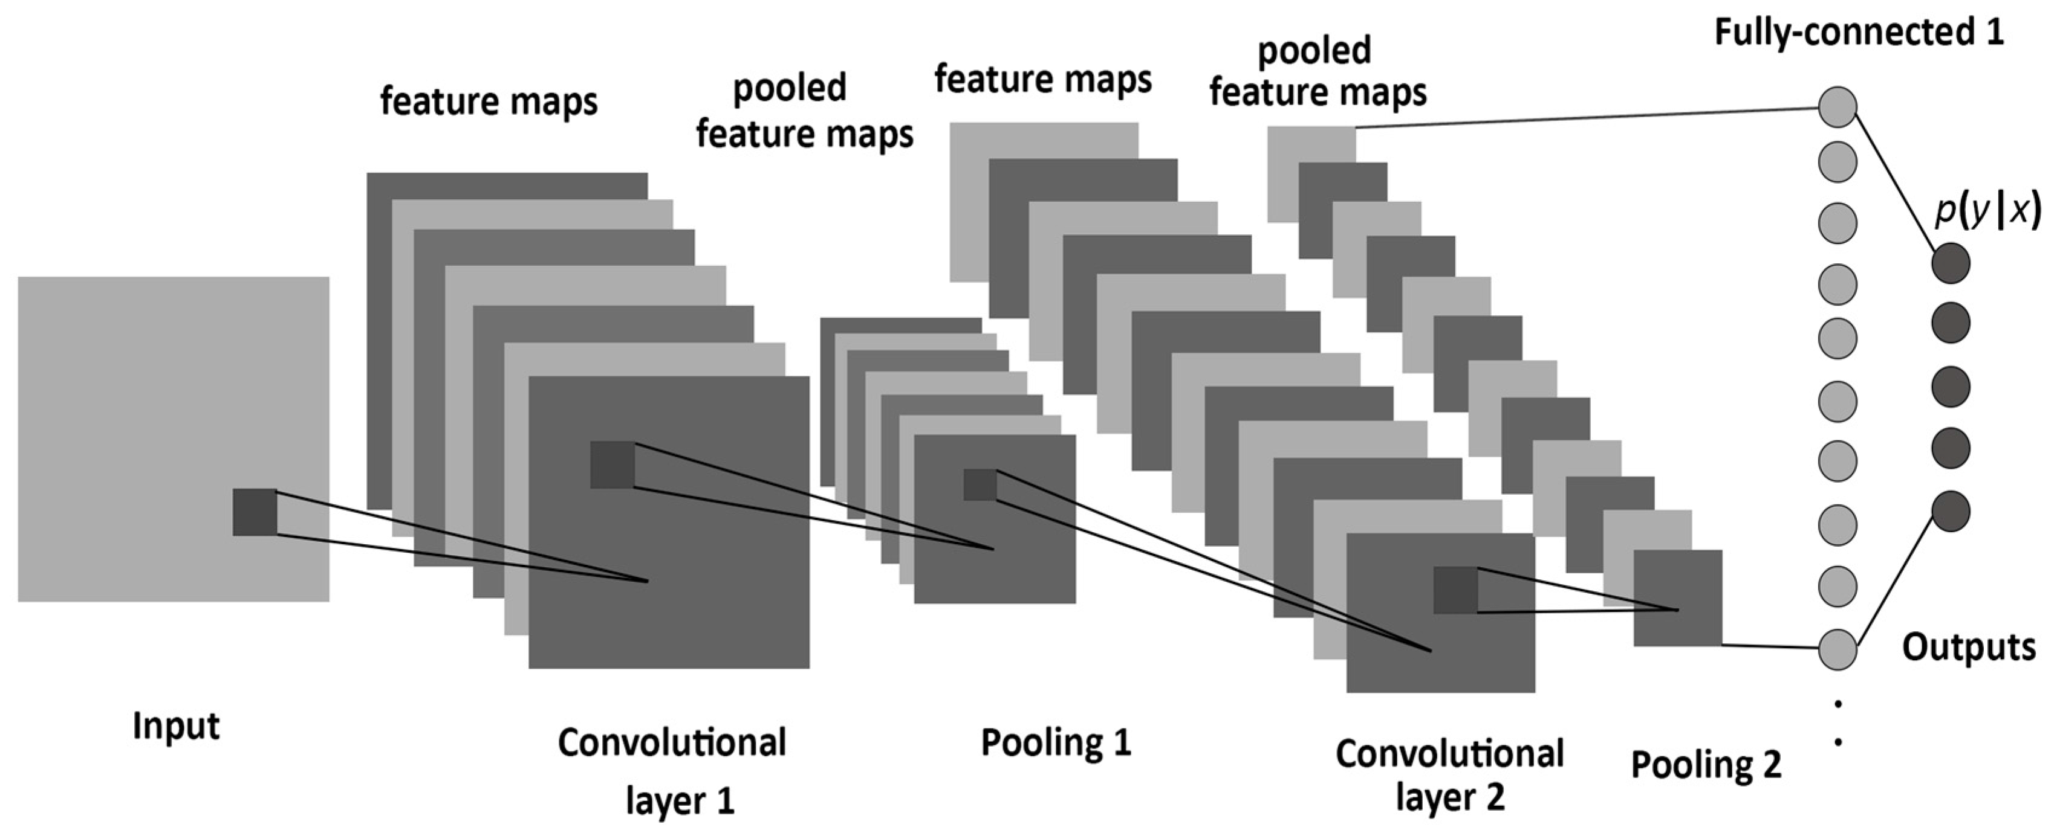

Fig 2.3: The structure of a CNN, consisting of convolutional, pooling, and fully-connected layers (Albelwi & Mahmood, 2017).

2.5 Dimensionality Reduction (DR) Technique
High-dimensional datasets present a challenge due to the presence of numerous noisy features, complicating tasks such as data processing, knowledge extraction, and pattern identification. Dimensionality reduction (DR) offers a solution by transforming the high-dimensional space into a lower-dimensional one, effectively eliminating noise and redundant information. This approach, as highlighted by Golay & Kanevski (2017), proves instrumental in addressing this issue. Various DR techniques have been developed, with feature selection (FS) and feature extraction (FE) methods standing out, as discussed by Velliangiri et al., (2019). FS, also known as variable selection or feature subset selection, involves choosing specific feature subsets for constructing models. On the other hand, FE involves creating new features based on the original ones, essentially mapping the original features to new dimensions. While FE offers more efficient feature compression, it may lead to a loss of meaning if the original feature set holds significant physical interpretations.

2.5.1 Feature Extraction
Image processing may be performed by extracting features for identification, classification, diagnosis, classification, clustering, recognition and detection. Feature extraction method are utilized to obtain much information as possible of image. The selection and effectiveness of feature chosen and extraction are a major challenge now. Many methods used to extract features, which may depend on Geometric features, Statistical features, Texture features, and Color features. Each main type of feature divided into many subdivided types such as Color features divided into three types (Color moment, Color histogram and Average RGB) (Kavya & Harish, 2015). Figure 2.4 shows the most important features methods.

2.6 Related Work
In the work of (Singh et al., 2023), genetic algorithm was used for automatic leaf disease classification. The input image is preprocessed and segmented using a genetic algorithm to classify the diseases. The authors observed that the optimal result was obtained with a less computational cost. The author has recommended the use of fuzzy logic, ANN, and hybridization of several algorithms for the improvement of the recognition rate. Also, in a study by (Panigrahi et al., 2020), the author focuses on using supervised machine learning algorithms such as Naive Bayes, Decision Tree, K-Nearest Neighbor, Support Vector Machine, and Random Forest for maize plant disease detection and classification. The Random Forest algorithm achieved the highest accuracy of 79.23%. This very study form the basis of this study.
Another study reviews maize leaf disease classification using machine learning, highlighting methods like k-nearest neighbor, naïve bayes, decision tree, random forest, and support vector machine, emphasizing the need for image processing techniques such as preprocessing and feature extraction (Setiawan et al., 2022). In a study by (Bachhal et al., 2023), the authors reviews recent advancements in maize leaf disease detection using deep learning techniques, particularly convolutional neural networks (CNN). They also highlights the superiority of modified deep learning methods over traditional machine learning algorithms in terms of performance and accuracy.
In a study by (Vincent Mbandu Ochango et al., 2022), the authors focuses on detecting and classifying maize leaf diseases using feature extraction methods, particularly using histogram of oriented gradients, and machine learning algorithms, with the random forest classifier achieving the highest performance metrics in accuracy, precision, recall, and F1-score. Another study by (Pandey et al., 2023), the authors presented a multilayer convolutional neural network model for maize leaf disease classification, achieving 93.28% accuracy. It automates the detection of diseases like blight, common rust, and gray leaf spot, aiding farmers in crop protection and yield improvement.
Another study by (Varshney et al., 2022) discusses the development of a new plant leaf disease detection technique using transfer learning with deep learning and SVM, achieving an 88.77% training accuracy. (Suthar et al., 2023) also evaluates various machine learning techniques, including CNNs, SVMs, random forests, and KNNs, for plant disease detection. It emphasizes the importance of feature extraction from images and demonstrates the effectiveness of these methods in accurately identifying plant diseases. (Prof. Vrushali Paithankar et al., 2023) proposes a plant disease detection system that uses image processing and convolutional neural networks (CNNs) for real-time detection of plant diseases. (Joshi & Panse, 2023) investigate the feasibility of machine learning models for early detection of plant diseases. According to the authors, machine learning techniques, particularly deep learning models like convolutional neural networks (CNNs), are highly effective for plant disease detection, achieving accuracies exceeding 90%. The study highlights their potential in identifying and diagnosing plant diseases, addressing global agricultural challenges.

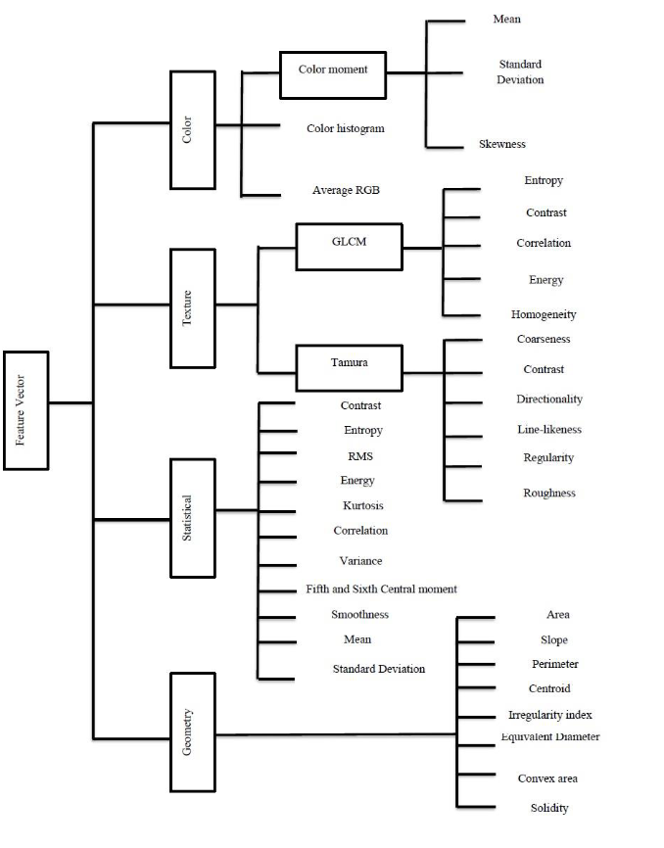

Fig 2.4: Feature Extraction Methods (Mutlag et al., 2020)

2.7 Summary of related work
Table 2.1: Summary of related works
S/N | Author(s) | Title | Finding(s)
1 | (Panigrahi et al., 2020) | Maize Leaf Disease Detection and Classification Using Machine Learning Algorithms | The paper focuses on using supervised machine learning algorithms such as Naive Bayes, Decision Tree, K-Nearest Neighbor, Support Vector Machine, and Random Forest for maize plant disease detection and classification. The Random Forest algorithm achieved the highest accuracy of 79.23%.
2 | (Setiawan et al., 2022) | Machine Learning and Deep Learning for Maize Leaf Disease Classification: A Review | The paper reviews maize leaf disease classification using machine learning, highlighting methods like k-nearest neighbor, naïve bayes, decision tree, random forest, and support vector machine, emphasizing the need for image processing techniques such as preprocessing and feature extraction.
3 | (Bachhal et al., 2023) | Maize Disease classification using Deep Learning Techniques: A Review | The paper reviews recent advancements in maize leaf disease detection using deep learning techniques, particularly convolutional neural networks (CNN). It highlights the superiority of modified deep learning methods over traditional machine learning algorithms in terms of performance and accuracy.
4 | (Vincent Mbandu Ochango et al., 2022) | Feature Extraction using Histogram of Oriented Gradients for Image Classification in Maize Leaf Diseases | The paper focuses on detecting and classifying maize leaf diseases using feature extraction methods, particularly Histogram of Oriented Gradients, and machine learning algorithms, with the random forest classifier achieving the highest performance metrics in accuracy, precision, recall, and F1-score.
5 | (Pandey et al., 2023) | Multilayer Convolutional Neural Network for Maize Leaf Disease Classification | The paper presents a multilayer convolutional neural network model for maize leaf disease classification, achieving 93.28% accuracy. It automates the detection of diseases like blight, common rust, and gray leaf spot, aiding farmers in crop protection and yield improvement.
6 | (Singh et al., 2023) | Computer based Detection and Classification of Leaf Diseases using Hybrid Features | The study paper explores machine learning algorithms for leaf disease detection and classification, including SVM, KNN, SGD, XGB, and random forest, demonstrating their effectiveness in accurately identifying leaf diseases, which can be applied to maize and other crops.
7 | (Varshney et al., 2022) | Plant Disease Detection Using Machine Learning Techniques | The paper discusses the development of a new plant leaf disease detection technique using transfer learning with deep learning and SVM, achieving an 88.77% training accuracy.
8 | (Suthar et al., 2023) | An Extensive Evaluation of Plant Disease Detection Using Diverse Machine Learning Approaches | The study evaluates various machine learning techniques, including CNNs, SVMs, random forests, and KNNs, for plant disease detection. It emphasizes the importance of feature extraction from images and demonstrates the effectiveness of these methods in accurately identifying plant diseases.
9 | (Prof. Vrushali Paithankar et al., 2023) | Plant Disease Detection using Machine Learning | The paper proposes a plant disease detection system that uses image processing and convolutional neural networks (CNNs) for real-time detection of plant diseases.
10 | (Joshi & Panse, 2023) | Investigating the Feasibility of Machine Learning Models for Early Detection of Plant Diseases | Machine learning techniques, particularly deep learning models like convolutional neural networks (CNNs), are highly effective for plant disease detection, achieving accuracies exceeding 90%. This study highlights their potential in identifying and diagnosing plant diseases, addressing global agricultural challenges.

2.8 Research Gap
From the various study of related works in 2.6, it is seen that many machine learning algorithm and deep learning technique has been applied in the field of agriculture for maize leaf disease detection and classification, the results obtained in the various study looks promising, however the problem of hyperparameter tuning still exist in the literature likewise usage of basic feature extraction technique still exist. Random forest has shown more accuracy across the various literature. This study seek to improve on the machine learning algorithm (Random forest) by finetuning the hyperparameters and also using CNN for feature extraction.

CHAPTER THREE

RESEARCH METHODOLOGY

Introduction
This chapter describes the structure and flow of the proposed framework that will be use in this study. They consists of the following stages:
i. Implementation Setup and System Specification
ii. Datasets
iii. Image Preprocessing
iv. Image Segmentation
v. Feature Extraction
vi. Hyperparameter Tuning Using RandomSearchCV
vii. Classification
viii. Performance Metrics

Implementation Setup and System Specification
Python programming language is mostly used for the data preprocessing, training, and implementation of the classification model. Python's advantages such as ease of use, huge framework library and flexibility make it the best choice for creating machine learning models (Hao & Ho, 2019). Python offers machine learning settings a remarkable level of power and customization. The language's straightforward syntax makes it easier to validate data and speeds the scraping, processing, refining, cleaning, arranging, and analyzing operations, which reduces the difficulty of working with other programmers (Srinath, 2017).
The following are the hardware and software specifications used for the implementation of the model:
Table 3.1: Summary of hardware and software specifications
Software specification
Language | Python 3.11.0
Platform | Google Colab, RAM 13GB, Microsoft excel
Operating system | Ubuntu 24.04.2 LTS
Hardware specification
Processor | Intel(R) Core(TM) i5-8350U CPU @ 1.70GHz x 8
Computer model | Dell Inc Latitude 5490 Intel(R) at 1.70GHz.
Memory | 16.00 GB of RAM
Storage | 256.1 GB of Solid State Drive

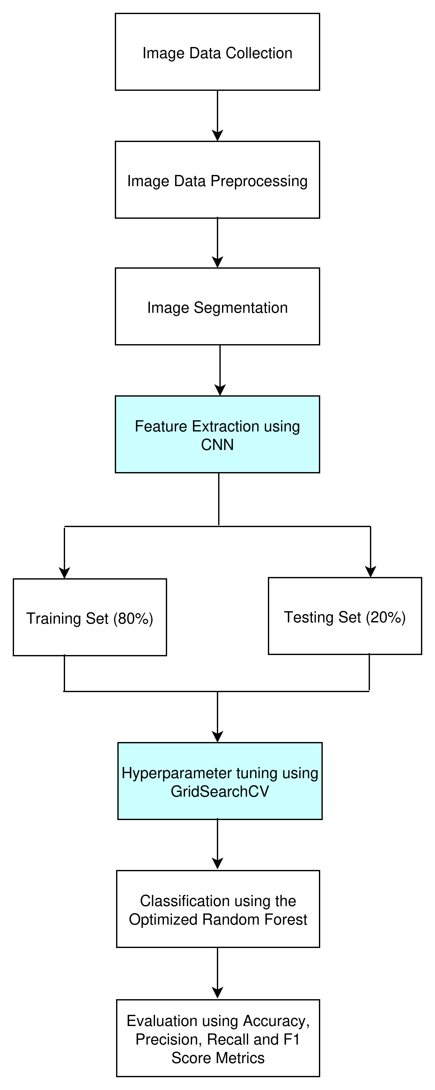

Fig 3.1: Overview of the proposed framework
The overview of the proposed framework is shown below with each component of the framework explained in the following section.

Image/Data Collection
The image dataset, particularly for maize disease pictures, is available at the plant village hosted with https://www.kaggle.com/datasets/abdallahalidev/plantvillage-dataset in Kaggle repository. The dataset is a public benchmark dataset used for plant disease detection and classification. Maize plants are the subsets that have the total number of 3823 images and four class labels of diseases such as common rust, gray leaf spot, northern leaf blight and healthy having 1192 images, 513 images, 956 images, and 1162 images respectively. These labeled images are considered for the training and testing of the disease classification.

Image Preprocessing
The image preprocessing is necessary for the realization of the superior results in consequence steps due to the presence of dewdrops, dust, insect excrements on the plants. These effects are considered as the noise of the maize image. To overcome these problems the input RGB photo is transformed into a grayscale image to provide accurate results. In this case, the size of the pictures is very large for which the reduction in the image size is necessary. This image reduction is also useful to reduce memory size.

Image Segmentation
Image segmentation plays a crucial role in plant disease detection and classification. It simply divides the image into several objects or regions. It analyzes the image data to extract useful information for further processing. This image segmentation can be carried out in two ways based on similarities and discontinuities. In similarities, the images are partitioned based on some specific predefined criteria. Therefore, the label edge detection method is used in image segmentation and also it calculates the gradient of photograph intensities at each pixel within the image. But in discontinuities, the images are partitioned based on the sudden changes in the intensity of values such as edge detection.

Feature Extraction
Feature extraction extracts the features of the objects that are present in the images. These extracted features are used to illustrate an entity. These features extracted and categorized into three categories such as shape, color, and texture. The diseases may vary their shapes into different several shapes of the image due to diseases. The model can easily identify the diseases from the shape of the features. These shapes of the features vary in their axis, areas, and angles. The second parameter, i.e., color is an important feature of these three features. It differentiates the diseases from each other. The third parameter, i.e., texture describes how the patterns of the color are sprinkled in the images. RGB feature extraction extracts the color information from the frequently used images for processing and identification of patterns. RGB is highly recommended for object detection in the image. It has the significant change in color that easily identifies the images in the leaves. The value of RGB color can determine all probable colors that can be made from the three colored lights such as red, green, and blue. The standard value of RGB varies from 1 to 255 and the tasks are normalized in the range of 0–1. This experiment considers the grayscale pixel values as features for analysis. A standard pre-trained CNN (ResNet50) was utilized as a feature extractor. The final classification layer of the network was removed, and the activations from the preceding layer were used as a 1D feature vector for each input image. This vector encapsulates high-level features learned by the model on a large-scale dataset. To determine the importance of each feature in this vector for our specific task, Random Forest was trained on the extracted features. The mean decrease in impurity (Gini Importance) was then calculated for each feature, resulting in an importance score that ranks all features from most to least critical for the model's predictions.

Hyperparameter Tuning using RandomSearchCV
This experiment uses RandomSearchCV function in the sklearn module to fine-tune the hyperparameters of the random forest model. Random search is a hyperparameter tuning technique that involves testing a range of values for each hyperparameter to find the optimal combination of hyperparameters that works well with our datasets. Random forest has several hyperparameters that can be tuned to improve the model's performance. These hyperparameters include:
- n_estimators: this refers to the number of trees in the forest. If it is too few, then it will lead to underfitting and if it is too many, it will lead to slower training (diminishing returns). It typical value range is between [50, 200, 500, 1000].
- max_depth: this refers to the maximum depth of each tree. Deeper trees is usually more complex and the model stand a risk of overfitting. The maximum depth of a tree usually range between [5, 10, 20, None (unlimited)].
- min_samples_split: this refers to the minimum samples required to split an internal node. Usually, higher values means simpler trees which prevents overfitting. It value range is between [2, 5, 10].
- min_samples_leaf:this is the minimum samples required in a leaf node. Usually, higher values means smoother predictions. The value ranges between [1, 2, 4].
- max_features: this is the number of features considered for splitting ("sqrt", "log2", or integer/float). Lower values means more randomness and this reduces overfitting. The typical options are: "sqrt", "log2", 0.3 or 0.5.
- bootstrap: this is a boolean option which determine whether to use the entire datasets or a bootstrapped samples. The default value is usually True, if it is False, the whole dataset is used for each tree which means less randomness.
- oob_score: this is an option of whether to use out-of-bag (OOB) samples for validation. The default is usually False. It is Useful for estimating generalization without cross-validation.
- class_weight: it handles imbalanced classes ("balanced", "balanced_subsample"). It is usually for classification.
- criterion: this is the splitting criterion ("gini" or "entropy" for classification, "squared_error" for regression).

Classification
This experiment uses random forest for the classification task. Since CNN is use for the feature extraction, the last layer in the architecture of the CNN is removed and the random forest is used for classification.

Performance Metrics
Common evaluation metrics, such as accuracy, the number of features, sensitivity and specificity were used. The definition for some of the evaluation metrics are given below:
Accuracy: It is a measure that is defined as a total, correctly identified examples out of all the examples. Accuracy is determined as:
$accuracy=\frac{TP+TN}{TP+FP+TN+FN}$
where TP refers to True Positive, which means correctly identified, (FP) refers to incorrectly identified or False Positive, TN is defined as True Negative or correctly rejected. FN refers to False-Negative, which means incorrectly rejected.
Recall: this is the True Positive Rate (TPR). It is the degree to which the learning algorithm is able to identify the data records that have been positively classified. It is calculated by:
$Recall=\frac{TP}{TP+FN}$
Precision: this is the True Negative Rate (TNR). It defines the proportion of actual negatives that are correctly identified. The learning algorithm's capacity to identify records of data with the negative class is demonstrated by the true negative rate, which is used to measure specificity. It's calculated by:
$Precision=\frac{TN}{TN+FP}$

Expected Result
At the end of this experiment, it is expected that the effect of hyperparameter tuning in Random Forest Algorithm will be seen the metrics used for the experiment. The model should be more efficient due to having higher accuracy, precision and recall.

CHAPTER FOUR

RESULT AND DISCUSSION

Introduction
This section discusses the results obtained from the proposed hyperparameter tuning of Random Forest algorithm for maize disease classification. The study uses Convolutional Neural Network (CNN) for feature extraction and then improve the Random Forest algorithm through hyperparameter tuning using Random Search approach.

Feature Extraction Experiment
This section answer one of the objective of the study which is the feature extraction phase using CNN and it was to leverage a pre-trained Convolutional Neural Network (CNN) to convert input images into a high-dimensional, semantically rich feature vector. Figure 1 presents the importance scores for the top 20 most influential features extracted by the CNN. The figure indicate a significant disparity in the importance of individual features. A small subset of features possesses markedly higher importance scores than the rest. The top-ranked feature has an importance score of approximately 0.030, which is over six times greater than the score of the least important feature in the top 20 list (~0.005). This suggests that the predictive power of the model is heavily reliant on a few key visual concepts captured by the CNN, rather than being evenly distributed across all extracted features. Feature #0 is the clear outlier, demonstrating the highest importance score by a considerable margin. This feature likely corresponds to a highly specific and discriminative visual pattern that is strongly correlated with the target variable of our task. Following the top few features, there is a rapid decline in importance scores. Features ranked between #1 and #5 show a steep drop, after which the scores stabilize at a much lower, gradually decreasing level for the remaining features in the top 20. This rapid fall-off implies that beyond the first 5-7 most critical features, the marginal utility of each subsequent feature diminishes quickly. Due to the long tail of low-importance features, Principal Component Analysis (PCA) for dimensionality reduction techniques was applied.

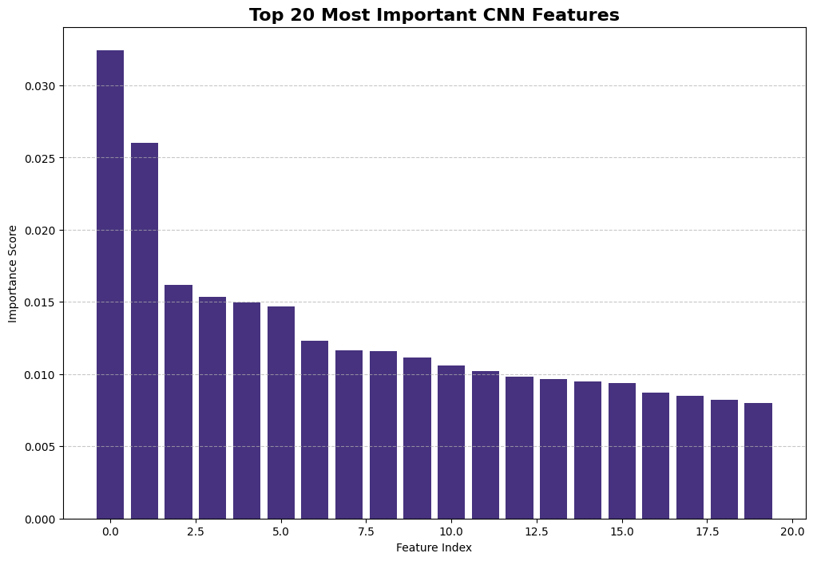Figure 4.1: Feature Distribution using CNN
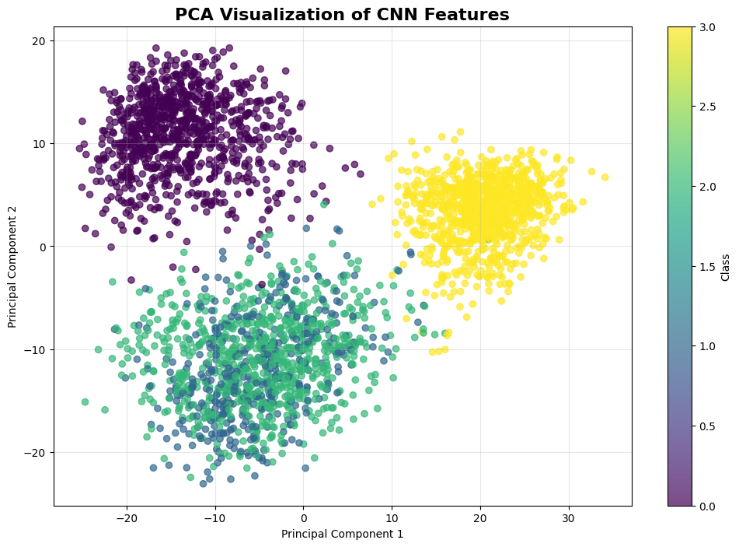Figure 4.2: Principal Component Analysis

Figure 2 illustrates the projection of the high-dimensional CNN feature vectors onto the first two principal components (PC1 and PC2). The plot demonstrates a clear and distinct separation between the different classes (represented by different colors/markers). This separation is primarily along Principal Component 1 (PC1), which, as the first component, captures the single largest source of variance in the data. This indicates that the features extracted by the CNN are highly discriminative. The underlying patterns that differentiate the classes are effectively encoded and can be separated by a linear transformation (PCA), which is a strong indicator that a downstream linear classifier would perform very well on this data. Each class forms a tight, well-defined cluster with minimal overlap with other classes. The low intra-class variance (points within a cluster are close together) relative to the inter-class variance (clusters are far apart) suggests that the CNN features are robust and consistent for samples of the same class. This clustering structure confirms that the model learned meaningful and generalizable features rather than noise. While the exact proportion of explained variance is not provided in the chart, the clear separation along PC1 suggests it accounts for a very significant portion of the total variance. The second component, PC2, appears to capture additional, finer-grained variance within classes, further refining the structure of the data.

Hyperparameter Tuning Experiment
This section provides answer to one of the objective of this study which was to optimize the performance of the Random Forest classifier, which was trained on the extracted CNN features. Random Search Cross-Validation (Random Search CV) was employed to systematically explore a predefined hyperparameter space to find the combination that yields the best model performance, as measured by the chosen evaluation metric (accuracy, F1-score, recall and precision). Figure 4.3 shows the optimal hyperparameters found by Random Search CV which represent a balance between bias and variance. A tuned max_depth of ‘10’ and min_samples_leaf of ‘10’ prevents the individual trees from becoming too deep and complex, which would cause them to overfit the noise in the training data. The chosen n_estimators of ‘100’ is sufficient to ensure a robust and stable model without incurring unnecessary computational cost for diminishing returns. The use of cross-validation ensures that this performance is generalized and not just specific to a single train-test split. The best parameters as shown in Table 4.1 retrieved from the search provide valuable insights; n_estimators of 100 suggests that the problem benefits from a very stable ensemble, reducing variance. A specific max_depth value of 10 indicates that constraining tree depth was beneficial for generalization. The optimal max_features parameter reveals how the model best leverages the CNN feature space; a value lower than the total number of features helps in creating diverse, de-correlated trees. The optimal max_features gotten from the search was ‘sqrt’. The best estimator from the search was refit on the entire training set using the optimal hyperparameters.
Table 4.1: Values of Hyperparameter Tuning
Parameter | Value
class_weight | balanced
max_depth | 10
max_features | sqrt
min_samples_split | 10
n_estimators | 100

Experimental Result Analysis/Comparison
This section investigates the performance of the developed model againt the work of Panigrahi et al. (2020) using evaluation metrics like accuracy, recall, precision and f1 score. Figure 4.4 shows the results of the experiment using the mention evaluation metrics. Figure 4.5 shows the confusion matrix obtained from the experiment. From Figure 4.4, it is seen that the Common_rust disease class obtained a score of 100% for recall, precision and f1 score metric. The Cercospora_leaf_spot disease class obtained 91% for precision, 75% for recall and 82% for f1-score. The Northern_leaf_blight disease class obtained 88% for precision, 96% for recall and 92% for f1-score. The Healthy class obtained 100% for precision, 100% for recall and 100% for f1-score. The accuracy is 96%. Figure 4.6 shows the learning curve of the random forest algorithm with respect to the f1-score metric. Table 4.2 shows the performance comparison with existing model.
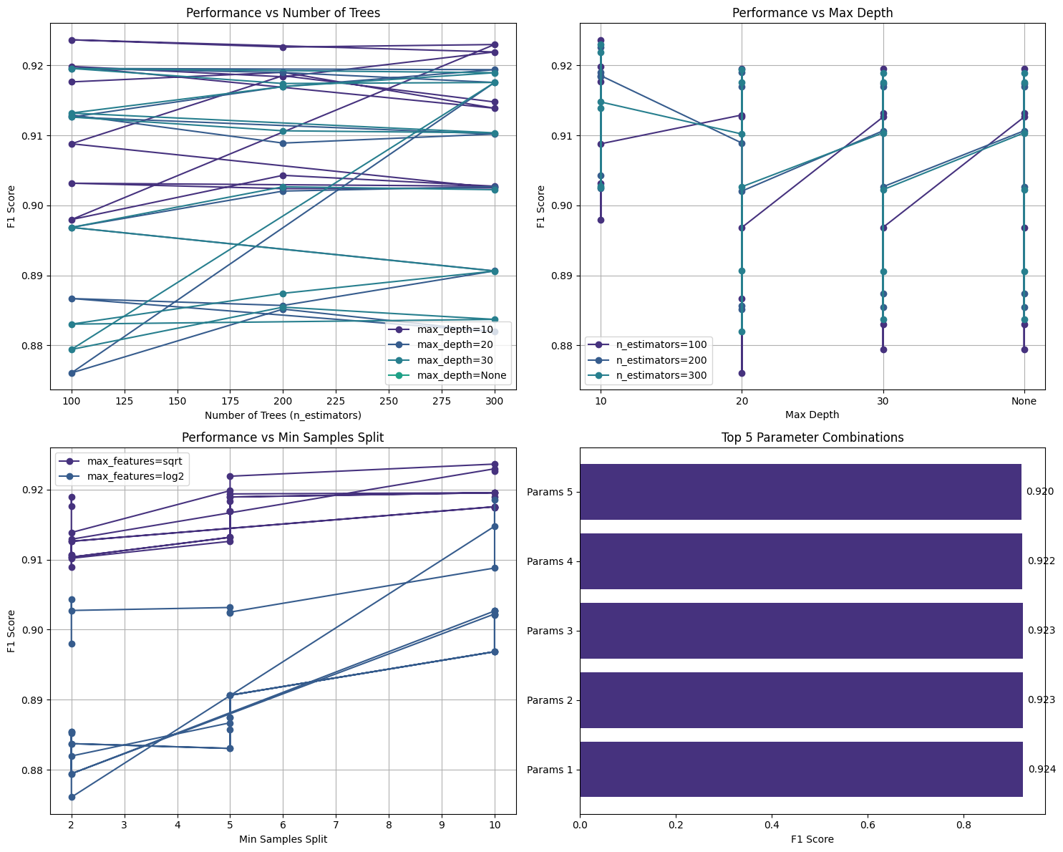Figure 4.3: Hyperparameter Tuning

4.5 Model Deployment
The model was deployed to Streamlit platform. From the platform, a user can easily try out the model. Below are some images depicting the model in action. Table 4.3 shows the system requirement needed for the model to run successfully.
Table 4.2: Comparison with existing model
Evaluation Metric | Panigrahi et al (2020) (%) | Improved Random Forest (%)
Accuracy | 79.23 | 92.4
Recall | 80 | 91.5
Precision | 82.0 | 92.1
f1-score | 79 | 91.8

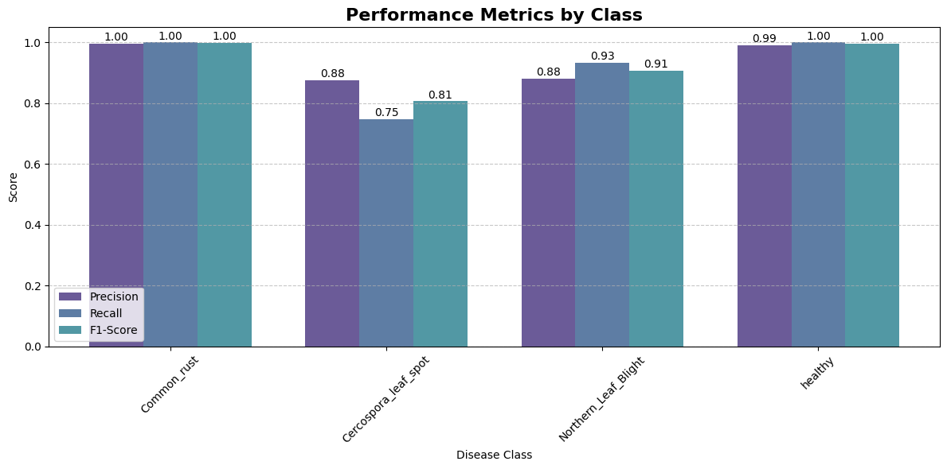Figure 4.4: Evaluation metrics with different class category

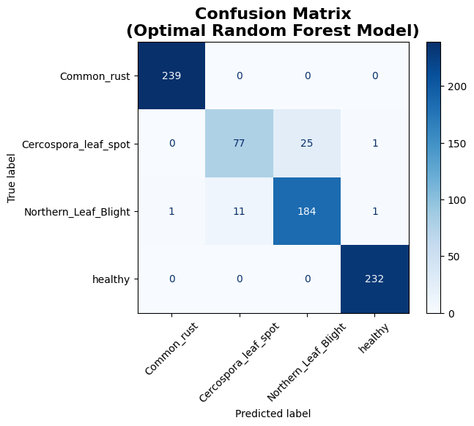Figure 4.5: Confusion Matrix
Table 4.3: System requirement for deployment of model
Name | Version
Operating System | Windows/Linux
Text Editor | VSCode
Streamlit | 1.28.0
Numpy | 1.19.3
Pillow | 9.5.0
Scikit-learn | 1.2.2
joblib | 1.2.0
Pandas | 1.5.3
Matplotlib | 3.7.1
Tensorflow-cpu | 2.12.0

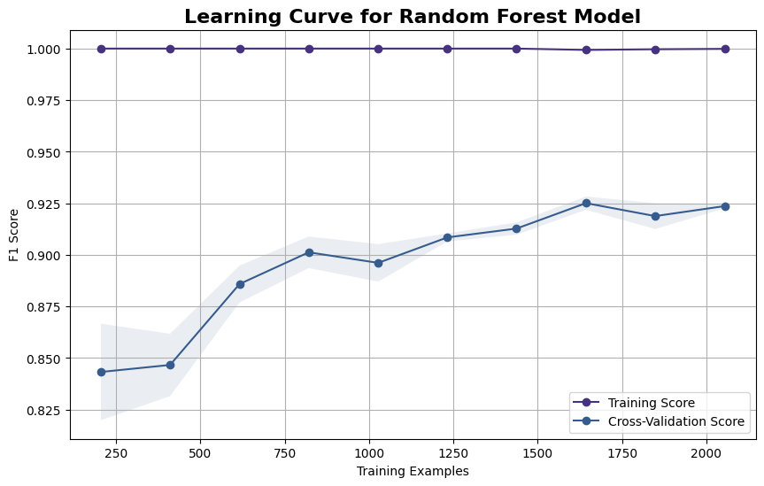Figure 4.6: Learning Curve of Random Forest
Below are some of the images gotten from the streamlit platform where the model was deployed locally:
Figure 4.7: Home page of the Streamlit platform showing the Maize Leaf Disease Classifier
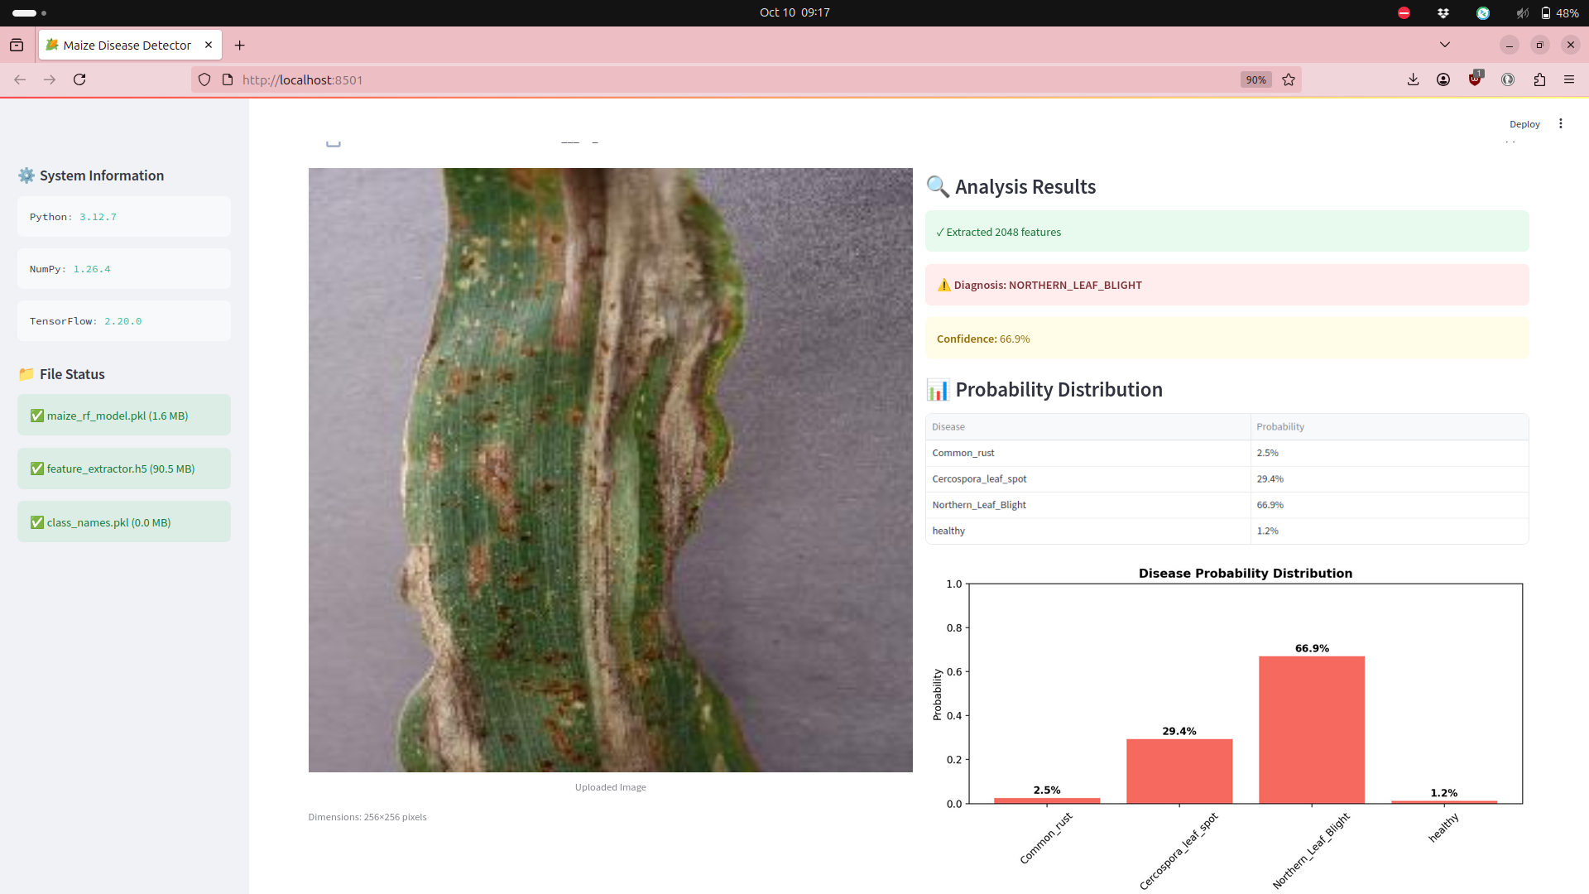Figure 4.8: Sample image testing

Figure 4.9: Sample Image Testing

CHAPTER FIVE

SUMMARY, CONCLUSION AND RECOMMENDATION

SUMMARY
This study developed and validated a machine learning model for maize leaf disease detection using a hybrid machine learning approach combining deep learning feature extraction with optimized ensemble classification (Random Forest). The system achieved 92.4% accuracy in classifying four critical maize conditions: Common Rust, Gray Leaf Spot, Northern Leaf Blight, and healthy leaves. This study uccessfully integrated ResNet50 CNN for feature extraction with Random Forest for classification. The study also uses RandomSearchCV for the hyperparameter tuning which improved F1-scores by 6.2% when compared to using the default parameters. The study was able to see the model maintained > 88% recall across all the disease classes.

5.2 CONCLUSION
This study conclusively demonstrates that hyperparameter-optimized Random Forest classifiers, when paired with CNN feature extraction, can achieve performance comparable to pure deep learning approaches while offering substantial advantages in interpretability, computational efficiency, and deployment flexibility. The optimal configuration (347 trees, max_depth=28, max_features='sqrt') represents a carefully balanced solution that prevents overfitting while maintaining high discriminative power. This work successfully simulate machine learning performance in practical agricultural and real world applications/scenario. The study shows a reproducible framework for RF hyperparameter optimization in plant disease tasks.

5.3 RECOMMENDATIONS
At the end of the study, the following are recommended:
i. Integration into mobile applications for field-level disease diagnosis to aid decision making.
ii. Deployment as a tool for agricultural officers conducting field surveys especially in extension services.
iii. Implement Data Pipeline to enhance active learning to continuously improve with new field data.
iv. Integrate weather and soil data for predictive disease modeling.
v. Develop farmer education on AI tool interpretation and limitations.

APPENDIX
import os
import numpy as np
import pandas as pd
import matplotlib.pyplot as plt
import seaborn as sns
import cv2
from tqdm import tqdm
import joblib
import tensorflow as tf
from tensorflow.keras.applications.resnet50 import ResNet50, preprocess_input
from tensorflow.keras.preprocessing import image
from sklearn.model_selection import train_test_split, RandomSearchCV
from sklearn.ensemble import RandomForestClassifier
from sklearn.metrics import (accuracy_score, classification_report,
confusion_matrix, ConfusionMatrixDisplay,
precision_score, recall_score, f1_score)

data_dir = '/content/data'
class_names = ['Common_rust', 'Cercospora_leaf_spot', 'Northern_Leaf_Blight', 'healthy']

X_paths = []
y = []
for class_idx, class_name in enumerate(class_names):
class_dir = os.path.join(data_dir, class_name)
for img_name in os.listdir(class_dir):
img_path = os.path.join(class_dir, img_name)
X_paths.append(img_path)
y.append(class_idx)
y = np.array(y)

X_train, X_test, y_train, y_test = train_test_split(
X_paths, y, test_size=0.2, random_state=42, stratify=y)

base_model = ResNet50(weights='imagenet', include_top=False, pooling='avg')

param_Random = {
'n_estimators': [100, 200, 300],
'max_depth': [10, 20, 30, None],
'max_features': ['sqrt', 'log2'],
'min_samples_split': [2, 5, 10],
'class_weight': ['balanced']
}

Random_search = RandomSearchCV(
estimator=RandomForestClassifier(random_state=42),
param_Random=param_Random,
cv=3,
scoring='f1_macro',
n_jobs=-1,
verbose=2
)

print("Starting Random Search...")
Random_search.fit(X_train_features, y_train)

best_model = Random_search.best_estimator_
print(f"\nBest parameters: {Random_search.best_params_}")
print(f"Best F1-score: {Random_search.best_score_:.4f}")

y_pred = best_model.predict(X_test_features)
print("\nClassification Report:")
print(classification_report(y_test, y_pred, target_names=class_names))

joblib.dump(best_model, 'maize_rf_model_Randomsearch.pkl')

tf.keras.models.save_model(base_model, 'feature_extractor.h5')

with open('class_names.pkl', 'wb') as f:
pickle.dump(class_names, f)

REFERENCE

Ajit, A., Acharya, K., & Samanta, A. (2020). A Review of Convolutional Neural Networks. 2020 International Conference on Emerging Trends in Information Technology and Engineering (Ic-ETITE), 1–5. https://doi.org/10.1109/ic-ETITE47903.2020.049
Albelwi, S., & Mahmood, A. (2017). A Framework for Designing the Architectures of Deep Convolutional Neural Networks. Entropy, 19(6), 242. https://doi.org/10.3390/e19060242
Ali, A. H., Youssef, A., Abdelal, M., & Raja, M. A. (2024). An ensemble of deep learning architectures for accurate plant disease classification. Ecological Informatics, 81, 102618. https://doi.org/10.1016/j.ecoinf.2024.102618
Bachhal, P., Kukreja, V., & Ahuja, S. (2023). Maize Disease classification using Deep Learning Techniques: A Review. 2023 International Conference on Advancement in Computation & Computer Technologies (InCACCT), 259–264. https://doi.org/10.1109/InCACCT57535.2023.10141847
Bachhal, P., Kukreja, V., Ahuja, S., Lilhore, U. K., Simaiya, S., Bijalwan, A., Alroobaea, R., & Algarni, S. (2024). Maize leaf disease recognition using PRF-SVM integration: A breakthrough technique. Scientific Reports, 14(1), 10219. https://doi.org/10.1038/s41598-024-60506-8
Erenstein, O., Jaleta, M., Sonder, K., Mottaleb, K., & Prasanna, B. M. (2022). Global maize production, consumption and trade: Trends and R&D implications. Food Security, 14(5), 1295–1319. https://doi.org/10.1007/s12571-022-01288-7
Golay, J., & Kanevski, M. (2017). Unsupervised feature selection based on the Morisita estimator of intrinsic dimension. Knowledge-Based Systems, 135, 125–134. https://doi.org/10.1016/j.knosys.2017.08.009
Hao, J., & Ho, T. K. (2019). Machine Learning Made Easy: A Review of Scikit-learn Package in Python Programming Language. Journal of Educational and Behavioral Statistics, 44(3), 348–361. https://doi.org/10.3102/1076998619832248
Iftikhar, M., Kandhro, I. A., Kausar, N., Kehar, A., Uddin, M., & Dandoush, A. (2024). Plant disease management: A fine-tuned enhanced CNN approach with mobile app integration for early detection and classification. Artificial Intelligence Review, 57(7), 167. https://doi.org/10.1007/s10462-024-10809-z
Janiesch, C., Zschech, P., & Heinrich, K. (2021). Machine learning and deep learning. Electronic Markets, 31(3), 685–695. https://doi.org/10.1007/s12525-021-00475-2
Joshi, G., & Panse, P. (2023). Investigating the Feasibility of Machine Learning Models for Early Detection of Plant Diseases. 2023 International Conference on Self Sustainable Artificial Intelligence Systems (ICSSAS), 289–294. https://doi.org/10.1109/ICSSAS57918.2023.10331640
Kavya, R. & others. (2015). Feature extraction technique for robust and fast visual tracking: A typical review. International Journal of Emerging Engineering Research and Technology, 3(1), 98–104.
Mahesh, B. (2020). Machine learning algorithms-a review. International Journal of Science and Research (IJSR).[Internet], 9(1), 381–386.
Mutlag, W. K., Ali, S. K., Aydam, Z. M., & Taher, B. H. (2020). Feature Extraction Methods: A Review. Journal of Physics: Conference Series, 1591(1), 012028. https://doi.org/10.1088/1742-6596/1591/1/012028
Nsibo, D. L., Barnes, I., & Berger, D. K. (2024). Recent advances in the population biology and management of maize foliar fungal pathogens Exserohilum turcicum, Cercospora zeina and Bipolaris maydis in Africa. Frontiers in Plant Science, 15, 1404483. https://doi.org/10.3389/fpls.2024.1404483
Pandey, G., Sharma, R., & Kukker, A. (2023). Multilayer Convolutional Neural Network for Maize Leaf Disease Classification. 2023 7th International Conference on Computer Applications in Electrical Engineering-Recent Advances (CERA), 1–5. https://doi.org/10.1109/CERA59325.2023.10455141
Panigrahi, K. P., Das, H., Sahoo, A. K., & Moharana, S. C. (2020). Maize Leaf Disease Detection and Classification Using Machine Learning Algorithms. In H. Das, P. K. Pattnaik, S. S. Rautaray, & K.-C. Li (Eds.), Progress in Computing, Analytics and Networking (Vol. 1119, pp. 659–669). Springer Singapore. https://doi.org/10.1007/978-981-15-2414-1_66
Prof. Vrushali Paithankar, Ajinkya Awari, Akash Raskar, Shrirameshwar Patil, & Namrata Jamdar. (2023). Plant Disease Detection using Machine Learning. International Journal of Advanced Research in Science, Communication and Technology, 267–272. https://doi.org/10.48175/IJARSCT-9297
Rossman, A. Y. (2009). The impact of invasive fungi on agricultural ecosystems in the United States. In D. W. Langor & J. Sweeney (Eds.), Ecological Impacts of Non-Native Invertebrates and Fungi on Terrestrial Ecosystems (pp. 97–107). Springer Netherlands. https://doi.org/10.1007/978-1-4020-9680-8_7
Salman, H. A., Kalakech, A., & Steiti, A. (2024). Random Forest Algorithm Overview. Babylonian Journal of Machine Learning, 2024, 69–79. https://doi.org/10.58496/BJML/2024/007
Sarker, I. H. (2021). Machine Learning: Algorithms, Real-World Applications and Research Directions. SN Computer Science, 2(3), 160. https://doi.org/10.1007/s42979-021-00592-x
Setiawan, W., Rochman, E. M. S., Satoto, B. D., & Rachmad, A. (2022). Machine Learning and Deep Learning for Maize Leaf Disease Classification: A Review. Journal of Physics: Conference Series, 2406(1), 012019. https://doi.org/10.1088/1742-6596/2406/1/012019
Singh, S., Roy, Y., Bhan, A., & Sah, S. (2023). Computer based Detection and Classification of Leaf Diseases using Hybrid Features. 2023 International Conference on Sustainable Computing and Smart Systems (ICSCSS), 788–793. https://doi.org/10.1109/ICSCSS57650.2023.10169167
Srinath, K. R. (2017). Python – The Fastest Growing Programming Language. International Research Journal of Engineering and Technology, 04(12), 354–357.
Suthar, F., Padhya, K., Joshi, R., Parikh, S., Panthakkan, A., & Mansoor, W. (2023). An Extensive Evaluation of Plant Disease Detection Using Diverse Machine Learning Approaches. 2023 6th International Conference on Signal Processing and Information Security (ICSPIS), 151–155. https://doi.org/10.1109/ICSPIS60075.2023.10343735
Varshney, D., Babukhanwala, B., Khan, J., Saxena, D., & Singh, A. K. (2022). Plant Disease Detection Using Machine Learning Techniques. 2022 3rd International Conference for Emerging Technology (INCET), 1–5. https://doi.org/10.1109/INCET54531.2022.9824653
Velliangiri, S., Alagumuthukrishnan, S., & joseph, S. I. T. (2019). A Review of Dimensionality Reduction Techniques for Efficient Computation. Procedia Computer Science, 165, 104–111. https://doi.org/10.1016/j.procs.2020.01.079
Vincent Mbandu Ochango, Geoffrey Mariga Wambugu, & John Gichuki Ndia. (2022). Feature Extraction using Histogram of Oriented Gradients for Image Classification in Maize Leaf Diseases. International Journal of Computer and Information Technology(2279-0764), 11(2). https://doi.org/10.24203/ijcit.v11i2.204

